­­



Submitted to

:

Mam Humaira Batool

***BS-Software Engineering 4th-E***

Title: LAB Report 10-12

DBMS

Hamza Mehmood

Roll# SP-21-110

NUML-S21-23530



National University of Modern Languages

DBMS (MySQL)

# Lab Report 10 to 12

**Question # 01:**

Consider the Following Tables.

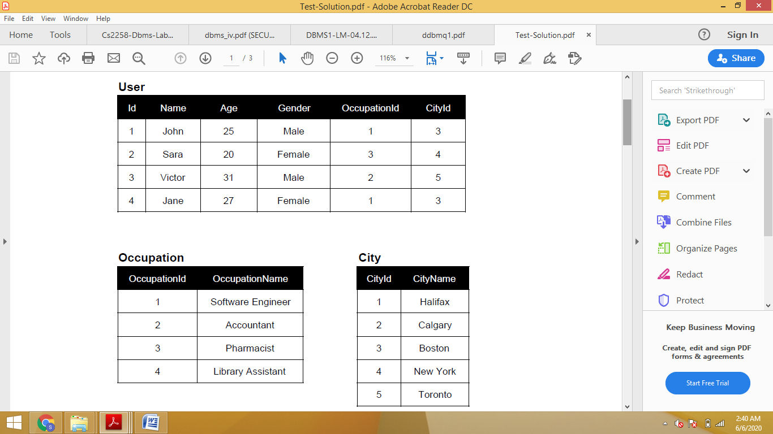

**Write down the SQL statements for Above Scenarios.**

For the above schema, perform the following:

1. Rename any table name:

**RENAME TABLE old_table_name TO new_table_name;**

Here is an example that renames the table customers to clients:

**RENAME TABLE Occupation TO Designation;**

1. Write a query to display the age, name where the age is greater than 20:

**SELECT Age, Name**

**FROM User**

**WHERE Age > 20;**

1. Display the name of all users where the second letter of the name is **a**.

**SELECT Name**

**FROM User**

**WHERE SUBSTRING (name, 2, 1) = 'a';**

1. Write a query to display the age, id where the age is not equal to 31 and id is greater than 2.

**SELECT Age, Id**

**FROM User**

**WHERE Age <> 31 AND Id > 2;**

1. Create a query to display the name concatenated with the gender, separated by comma and space. Name the column heading USER_DETAILS respectively.

**SELECT CONCAT (Name, ', ', Gender) AS USER_DETAILS**

**FROM User;**